Millers Pond State Park (Durham)
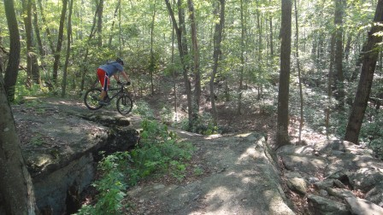

Directions
  - Take 95 South to Exit 69 for Route 9 North
  - Take Exit 9 for Route 81 and turn left
  - Turn left on to Candlewood Hill Road for about 3 miles
  - Turn right on to Foot Hills Road
  - Parking lot is on the left, 1.5 miles

Riding Tips
Trails are challenging but fun. A lot of rocks but nearly all are rideable. There are a lot of log rides, drops and rollers but there’s usually an easier way around the more challenging obstacles. The NEMBA website has a good description and the DEP has a good map.

Helpful Links
  - http://www.nemba.org/ridingzone/Millers_Pond_State_Park.html
  - http://www.ct.gov/dep/lib/dep/stateparks/maps/millerspondtrailmap.pdf
  - Parking Lot Location

