Bluff Point/Haley Farm State Park (Groton)
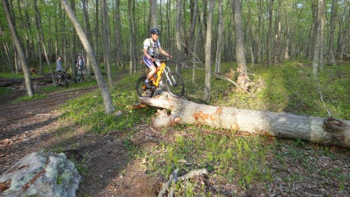

Directions
  - From Groton, Take Route 1 (Poquonnock Rd) North towards Mystic
  - Take right on to Depot Road (Dairy Queen is on left)
  - Pass under the railroad tracks (road turns to dirt and ends in a parking lot)

Riding Tips
Riding is mostly smooth and fast with some mild elevation changes. Maps can be difficult to follow because no trails are marked. You can’t go wrong if you stay on trails that look like they are well ridden. It will be difficult to get lost, the park is a peninsula and the fire roads provide good reference.
Bluff Point is connected to Haley Farm by a bridge over the railroad tracks. Trails are limited but worth exploring.

Helpful Links
  - http://www.bikerag.com/images/MAPS/ct-bluff_point_map.htm
  - http://www.nemba.org/ridingzone/Bluff_Point.html
  - http://www.crankfire.com/bike/trail/64/bluff_point_state_park

